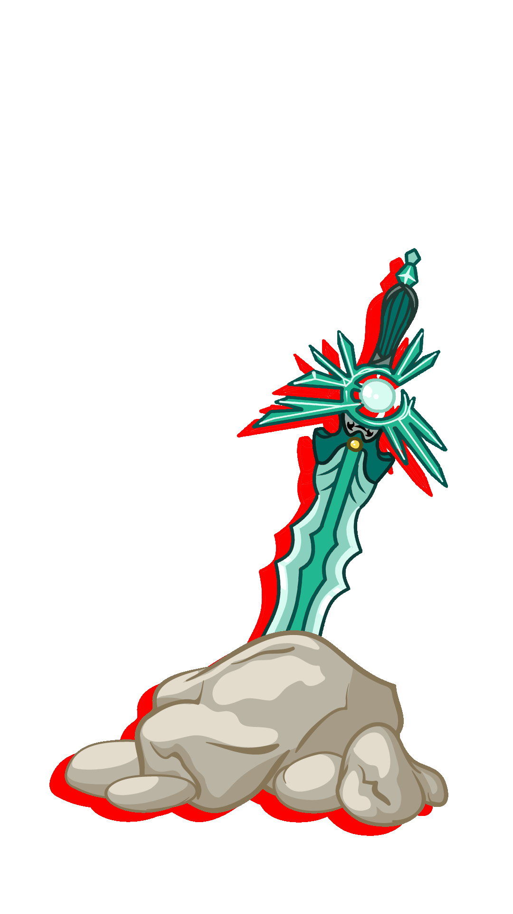

**INSTRUCTION MANUAL**



**INSTALLATION --------------------------------------- 1  
MAIN GAME ---------------------------------------- 2**

**MINIGAMES ---------------------------------------- 9**

**TABLE OF CONTENTS**



**Installation**



**SETTING UP YOUR DEVICE**

1. Go to Settings.
2. Scroll Down to Security.

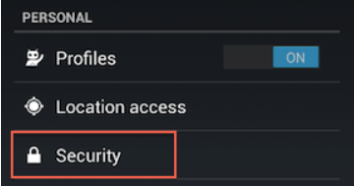

1. Select Unknown Sources (Selecting this option will allow you to install apps outside of the Google Play store).

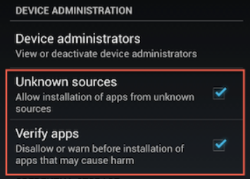

Note: Depending on your device, you can also choose to be warned before

installing harmful apps. This can be enabled by selecting the Verify apps

option in the Security settings.

**INSTALLING THE APP**

1. Open the “Pedro’s Journey” apk file.
2. Click “Install”.





**Main Game**

**STORY**

The story of Pedro’s Journey starts off with your self-named main character and his 2 friends near the end of the National Youth Day events with all the participants gathered around in one place as the NYD organizer is wrapping up the event with a speech.

     Before the event was even able to wrap up, portals appeared around the venue and shadow-like monsters appeared from the portals and started killing the participants. As the MC and his friends tried to escape the situation, they were eventually cornered by the shadows and his 2 friends had their souls taken away by the shadows.

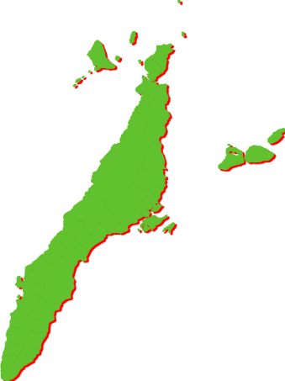

**CASTS**

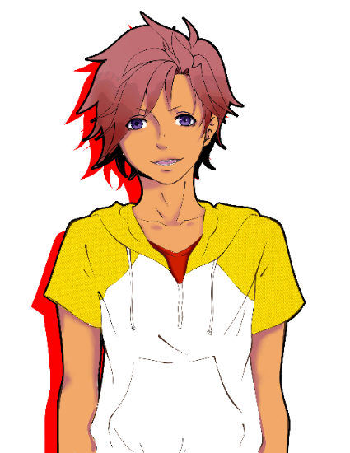

**Main Character**

He is your self-named main character of the story. He doesn't have a set name since the players will be naming him themselves.



**Pedro**

The secondary main character of the story. A spirit that gives the MC his supernatural powers, and assists the main character throughout his journey.



**Mysterious Figure**

A Mysterious Hooded Figure who appears and murders the Organizer in a split second, what could be his motives?

**Friend 1**

One of the main character’s friends

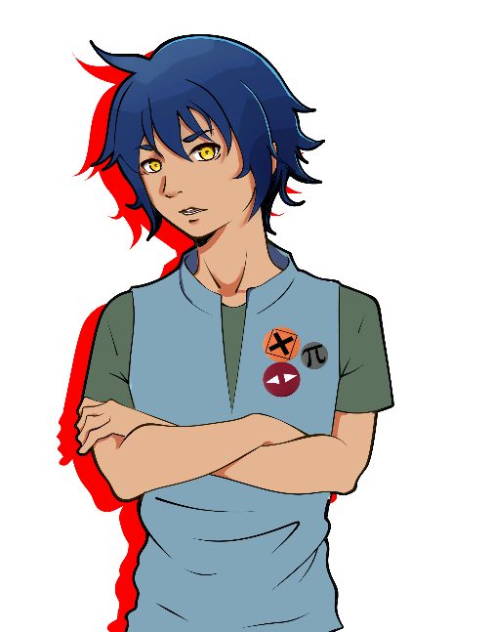

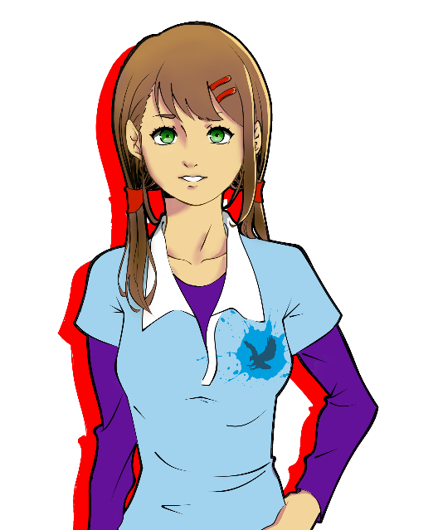

**Friend 2**

One of the main character’s friends

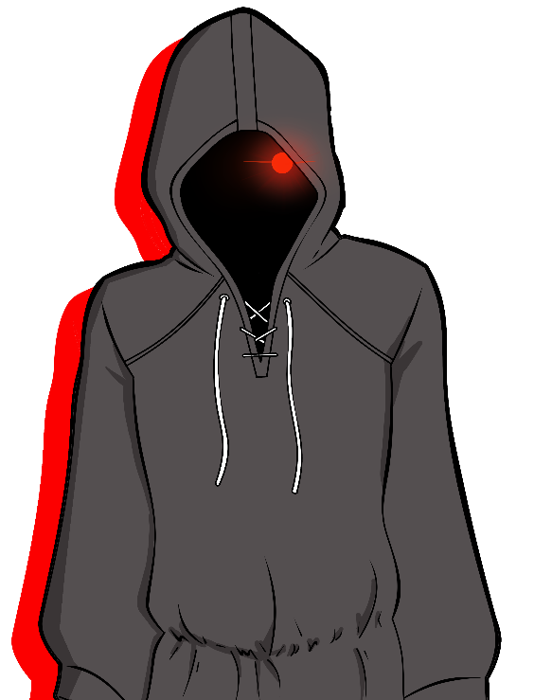



**Main Game Controls**

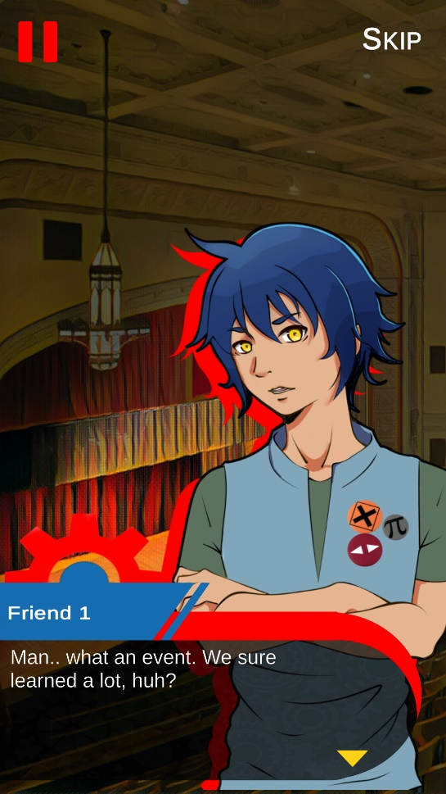

**PAUSE BUTTON**

**SKIP BUTTON**

**DIALOGUE BOX**

|  |  |
| --- | --- |
| PAUSE BUTTON | It enables the player to pause the game |
| SKIP BUTTON | It enables the player to skip the dialogue and engage battle right away |
| DIALOGUE BOX | It enables the user to proceed the with the dialogue |

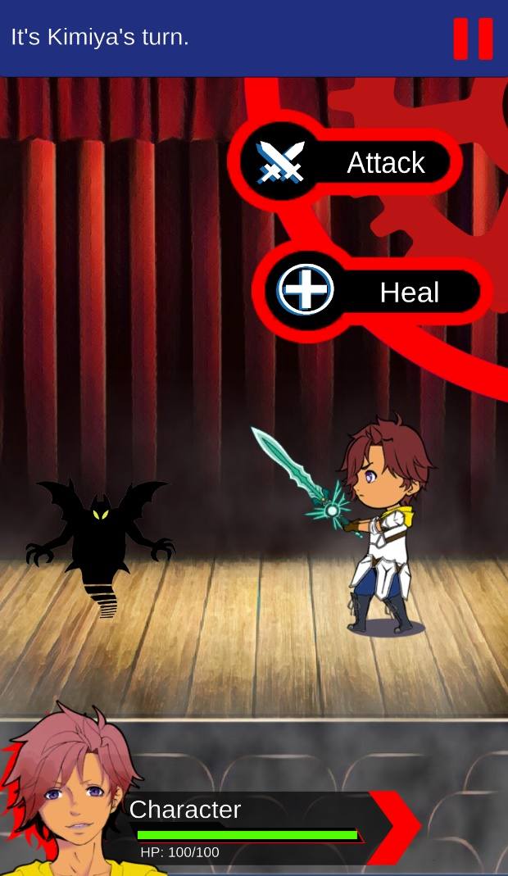

|  |  |
| --- | --- |
| PAUSE BUTTON | It enables the player to pause the game |
| ATTACK BUTTON | It enables the player to damage the enemy |
| HEAL BUTTON | It enables the player to heal the his/her character |
| HEALTH/HP BAR | It enables the player to see the remaining health of his/her character |

**HEALTH/HP BAR**

**PAUSE BUTTON**

**HEAL BUTTON**

**ATTACK BUTTON**

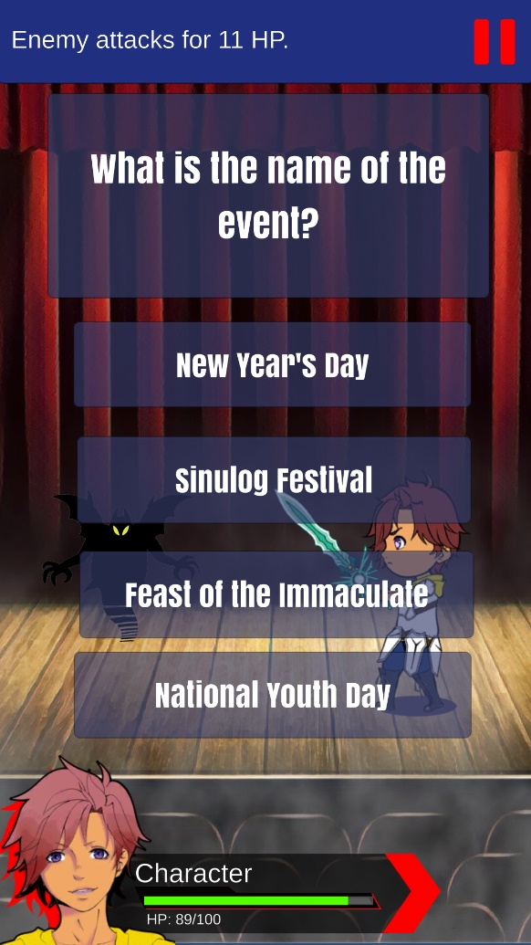

|  |  |
| --- | --- |
| QUESTIONAIRE BOX Module | It enables the player to see the given question |
| CHOICE BUTTON | It enables the player to tap and select the answer of his/her choice |

**CHOICE BUTTONS**

**QUESTIONAIRE BOX**

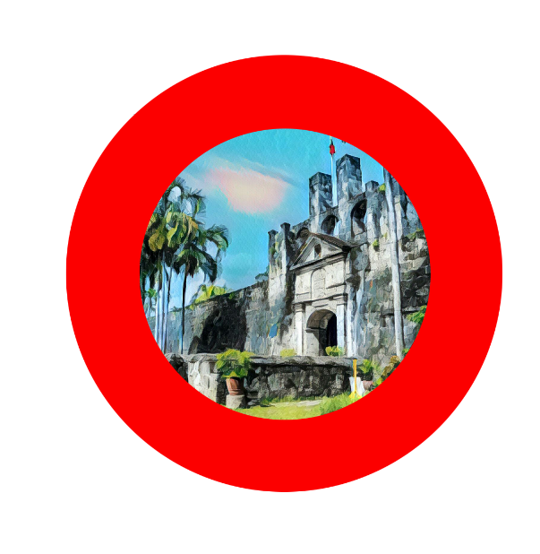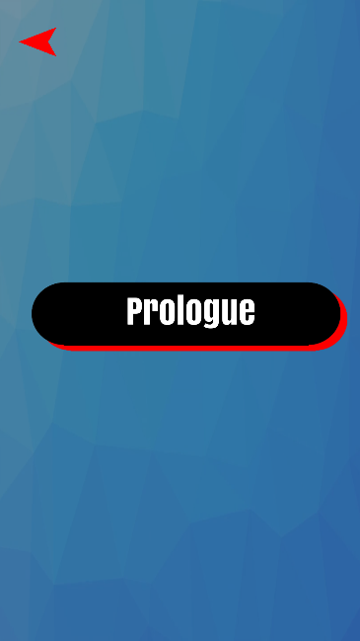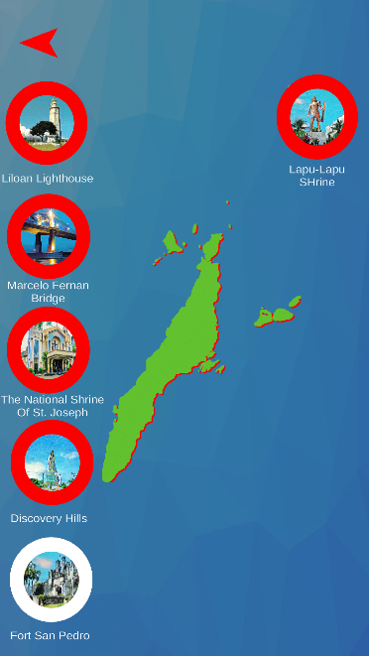

**MAIN GAME**

**Menus**

**LOCATION OR CHAPTER BUTTONS**

These buttons show the different locations of the island Cebu. Each of them contains different chapters of the story that took place on that location, but before you can gain access to its contents, you will need a specific QR Code of that location in order to unlock the contents of that chapter.

**MAP**

After playing with the Prologue Chapter you will be greeted with an extensive map of Cebu and shows different locations where the main story will take place.

**PROLOGUE**

Before gaining access to all the rest of the chapter you need to clear the prologue first to gain entry to the rest of the chapters. Press the Prologue button to play the “Prologue Chapter” of the main game.

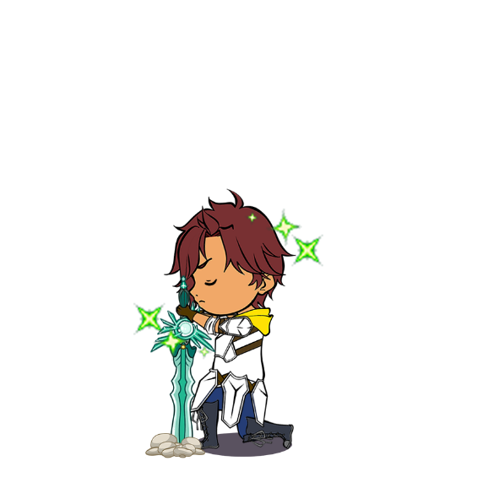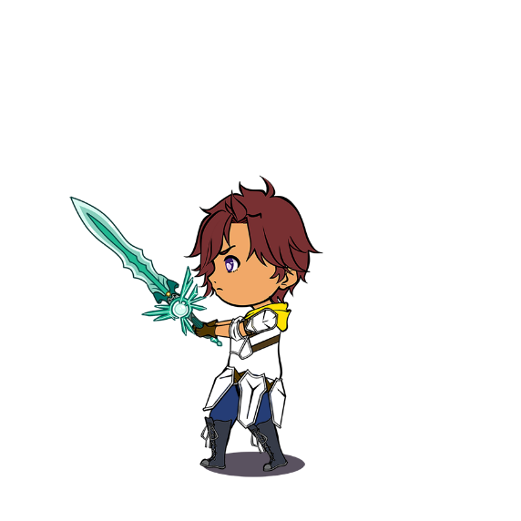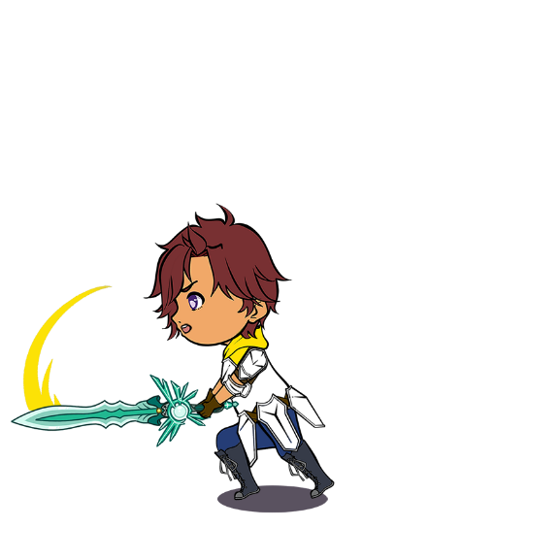

**BATTLE SYSTEM**

This game’s battle system is turn-based and each side has their respective turns. The main mechanic of each battle is having the player answer the questions and if the player doesn’t answer the question correctly, he/she will lose a turn.

**MAIN GAME**

**Battle**

**Heal**

Pressing this will allow the player to heal and regain some health points

**Attack**

Pressing this will allow the player to damage the enemy

**ABILITIES**



**BAMBOOZLE**

a crossword game where you form a set of letters to form words related to Cebu's history. Will have an easy, medium, and hard difficulty.

**QUOTATION EXAM**

a game where you fill in incomplete quotes from famous religious figures. It will be multiple choice.

**MEMORY MATCH**

a card game where the player matches 2 cardsthat have a relationship with each other out of several faced down cards.

Besides the main game, this app includes three mini games for the players to have fun with.

**MINIGAMES**